Laboratory Exercise 10

**Assignment 1:**



* Source code:

|  |
| --- |
| .eqv SEVENSEG_LEFT 0xFFFF0011 # Dia chi cua den led 7 doan trai.  # Bit0=doana;  # Bit1=doanb  # Bit7=dau.  .eqv SEVENSEG_RIGHT 0xFFFF0010 # Dia chi cua den led 7 doan phai  .text  main:  li $a0, 0x3F # set value for segments  jal SHOW_7SEG_LEFT # show  li $a0, 0x6F # set value for segments  jal SHOW_7SEG_RIGHT # show  exit: li $v0, 10  syscall  endmain:  #---------------------------------------------------------------  # Function SHOW_7SEG_LEFT : turn on/off the 7seg  # param[in] $a0 value to shown  # remark $t0 changed  #---------------------------------------------------------------  SHOW_7SEG_LEFT: li $t0, SEVENSEG_LEFT # assign port's address  sb $a0, 0($t0) # assign new value  jr $ra  #---------------------------------------------------------------  # Function SHOW_7SEG_RIGHT : turn on/off the 7seg  # param[in] $a0 value to shown  # remark $t0 changed  #---------------------------------------------------------------  SHOW_7SEG_RIGHT: li $t0, SEVENSEG_RIGHT # assign port's address  sb $a0, 0($t0) # assign new value  jr $ra |
|  |

* Some other values:



**Assignment 2:**



* Source code:

|  |
| --- |
| .eqv MONITOR_SCREEN 0x10010000  .eqv RED 0x00FF0000  .eqv GREEN 0x0000FF00  .eqv BLUE 0x000000FF  .eqv WHITE 0x00FFFFFF  .eqv YELLOW 0x00FFFF00 |
| .text  li $k0, MONITOR_SCREEN  li $t0, RED  sw $t0, 0($k0)  li $t0, GREEN  sw $t0, 4($k0)  li $t0, BLUE  sw $t0, 8($k0)  li $t0, WHITE  sw $t0, 12($k0)  li $t0, YELLOW  sw $t0, 32($k0) |

* Draw something:

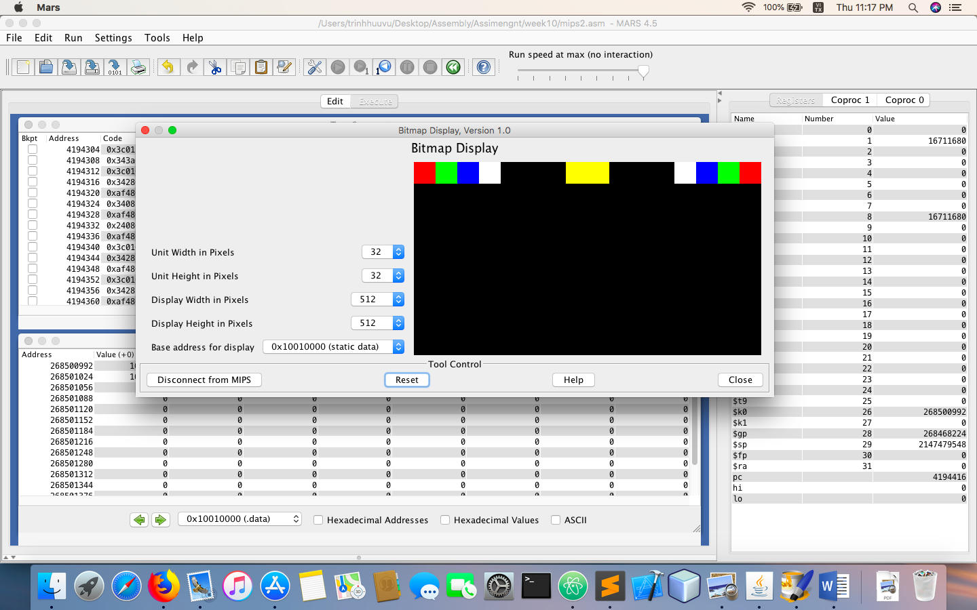

**Assignment 3:**



* Source code:

.eqv HEADING 0xffff8010 # Integer: An angle between 0 and 359

# 0 : North (up)

# 90: East (right)

# 180: South (down)

# 270: West (left)

.eqv MOVING 0xffff8050 # Boolean: whether or not to move

.eqv LEAVETRACK 0xffff8020 # Boolean (0 or non-0):

# whether or not to leave a track

.eqv WHEREX 0xffff8030 # Integer: Current x-location of MarsBot

.eqv WHEREY 0xffff8040 # Integer: Current y-location of MarsBot

.text

main:

jal TRACK # draw track line

addi $a0, $zero, 90 # Marsbot rotates 90* and start running

jal ROTATE

jal GO

sleep1:

addi $v0,$zero,32 # Keep running by sleeping in 1000 ms

li $a0,2000

syscall

jal UNTRACK # keep old track

jal TRACK # and draw new track line

goDOWN:

addi $a0, $zero, 180 # Marsbot rotates 180*

jal ROTATE

sleep2:

addi $v0,$zero,32 # Keep running by sleeping in 2000 ms

li $a0,2000

syscall

jal UNTRACK # keep old track

jal TRACK # and draw new track line

goDOWNRIGHT:

addi $a0, $zero, 135 # Marsbot rotates 270*

jal ROTATE

sleep3:

addi $v0,$zero,32 # Keep running by sleeping in 1000 ms

li $a0,5000

syscall

jal UNTRACK # keep old track

jal TRACK # and draw new track line

goUPRIGHT:

addi $a0, $zero, 45 # Marsbot rotates 120*

jal ROTATE

sleep4:

addi $v0,$zero,32 # Keep running by sleeping in 2000 ms

li $a0,5000

syscall

jal UNTRACK # keep old track

jal TRACK # and draw new track line

goLEFT:

addi $a0, $zero, 270 # Marsbot rotates 120*

jal ROTATE

sleep5:

addi $v0,$zero,32 # Keep running by sleeping in 2000 ms

li $a0,5000

syscall

jal UNTRACK # keep old track

jal TRACK # and draw new track line

end_main:

#-----------------------------------------------------------

# GO procedure, to start running

# param[in] none

#-----------------------------------------------------------

GO:

li $at, MOVING # change MOVING port

addi $k0, $zero,1 # to logic 1,

sb $k0, 0($at) # to start running

jr $ra

#-----------------------------------------------------------

# STOP procedure, to stop running

# param[in] none

#-----------------------------------------------------------

STOP:

li $at, MOVING # change MOVING port to 0

sb $zero, 0($at) # to stop

jr $ra

#-----------------------------------------------------------

# TRACK procedure, to start drawing line

# param[in] none

#-----------------------------------------------------------

TRACK:

li $at, LEAVETRACK # change LEAVETRACK port

addi $k0, $zero,1 # to logic 1,

sb $k0, 0($at) # to start tracking

jr $ra

#-----------------------------------------------------------

# UNTRACK procedure, to stop drawing line

# param[in] none

#-----------------------------------------------------------

UNTRACK:

li $at, LEAVETRACK # change LEAVETRACK port to 0

sb $zero, 0($at) # to stop drawing tail

jr $ra

#-----------------------------------------------------------

# ROTATE procedure, to rotate the robot

# param[in] $a0, An angle between 0 and 359

# 0 : North (up)

# 90: East (right)

# 180: South (down)

# 270: West (left)

#-----------------------------------------------------------

ROTATE:

li $at, HEADING # change HEADING port

sw $a0, 0($at) # to rotate robot

jr $ra

* Draw a triangle:

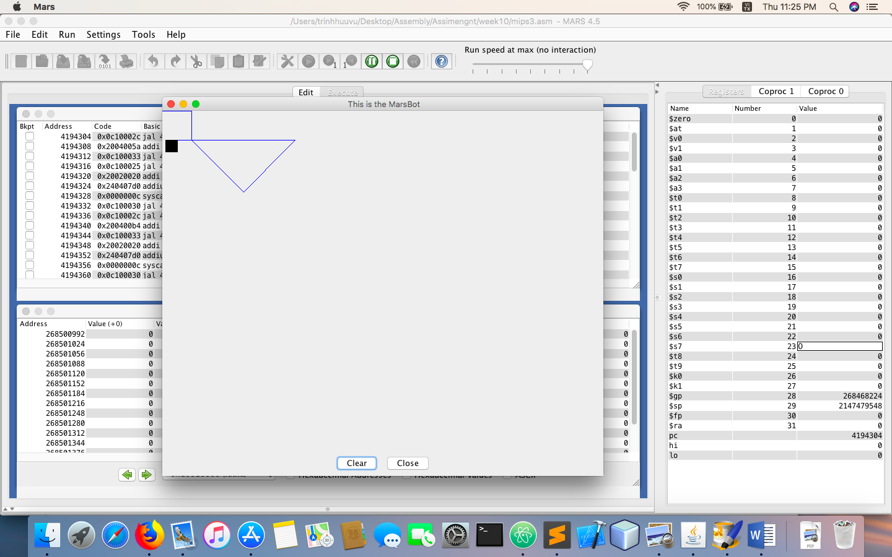

**Assignment 4:**



.eqv KEY_CODE 0xFFFF0004 # ASCII code from keyboard, 1 byte

.eqv KEY_READY 0xFFFF0000 # =1 if has a new keycode ?

# Auto clear after lw

.eqv DISPLAY_CODE 0xFFFF000C # ASCII code to show, 1 byte

.eqv DISPLAY_READY 0xFFFF0008 # =1 if the display has already to do

# Auto clear after sw

.text

li $k0, KEY_CODE

li $k1, KEY_READY

li $s0, DISPLAY_CODE

li $s1, DISPLAY_READY

loop: nop

WaitForKey:

lw $t1, 0($k1) # $t1 = [$k1] = KEY_READY

beq $t1, $zero, WaitForKey # if $t1 == 0 then Polling

ReadKey:

lw $t0, 0($k0) # $t0 = [$k0] = KEY_CODE

WaitForDis:

lw $t2, 0($s1) # $t2 = [$s1] = DISPLAY_READY

beq $t2, $zero, WaitForDis # if $t2 == 0 then Polling

ShowKey:

sw $t0, 0($s0) # show key

nop

CheckExit:

beq $t0, 101, to_state_1

beq $t0, 120, to_state_2

beq $t0, 105, to_state_3

beq $t0, 116, finish

to_state_0: # state 0: wait e

add $t3, $zero, $zero

j continue

to_state_1: # state 1: wait x

bne $t3, 0, to_state_0

add $t3, $t3, 1

j continue

to_state_2: # state 2: wait i

bne $t3, 1, to_state_0

add $t3, $t3, 1

j continue

to_state_3: # state 0: wait t

bne $t3, 2, to_state_0

add $t3, $t3, 1

j continue

finish:

bne $t3, 3, to_state_0

j exit

continue:

j loop

exit:

li $v0, 10

syscall